

ShoesShop

Author: John Doe
File name: ShoesShop.vp
Date: 5/14/24, 9:04 PM
Version: 1.0

Screens
01

01. Screens / ShoesShop
SplashScreen
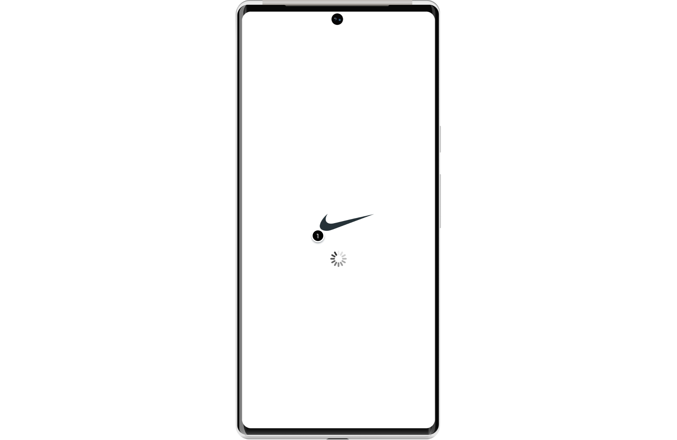

Interactions

1 | on Page Load: goes to 'AuthScreen' with effect: fade in 700ms

01. Screens / ShoesShop
LoginScreen
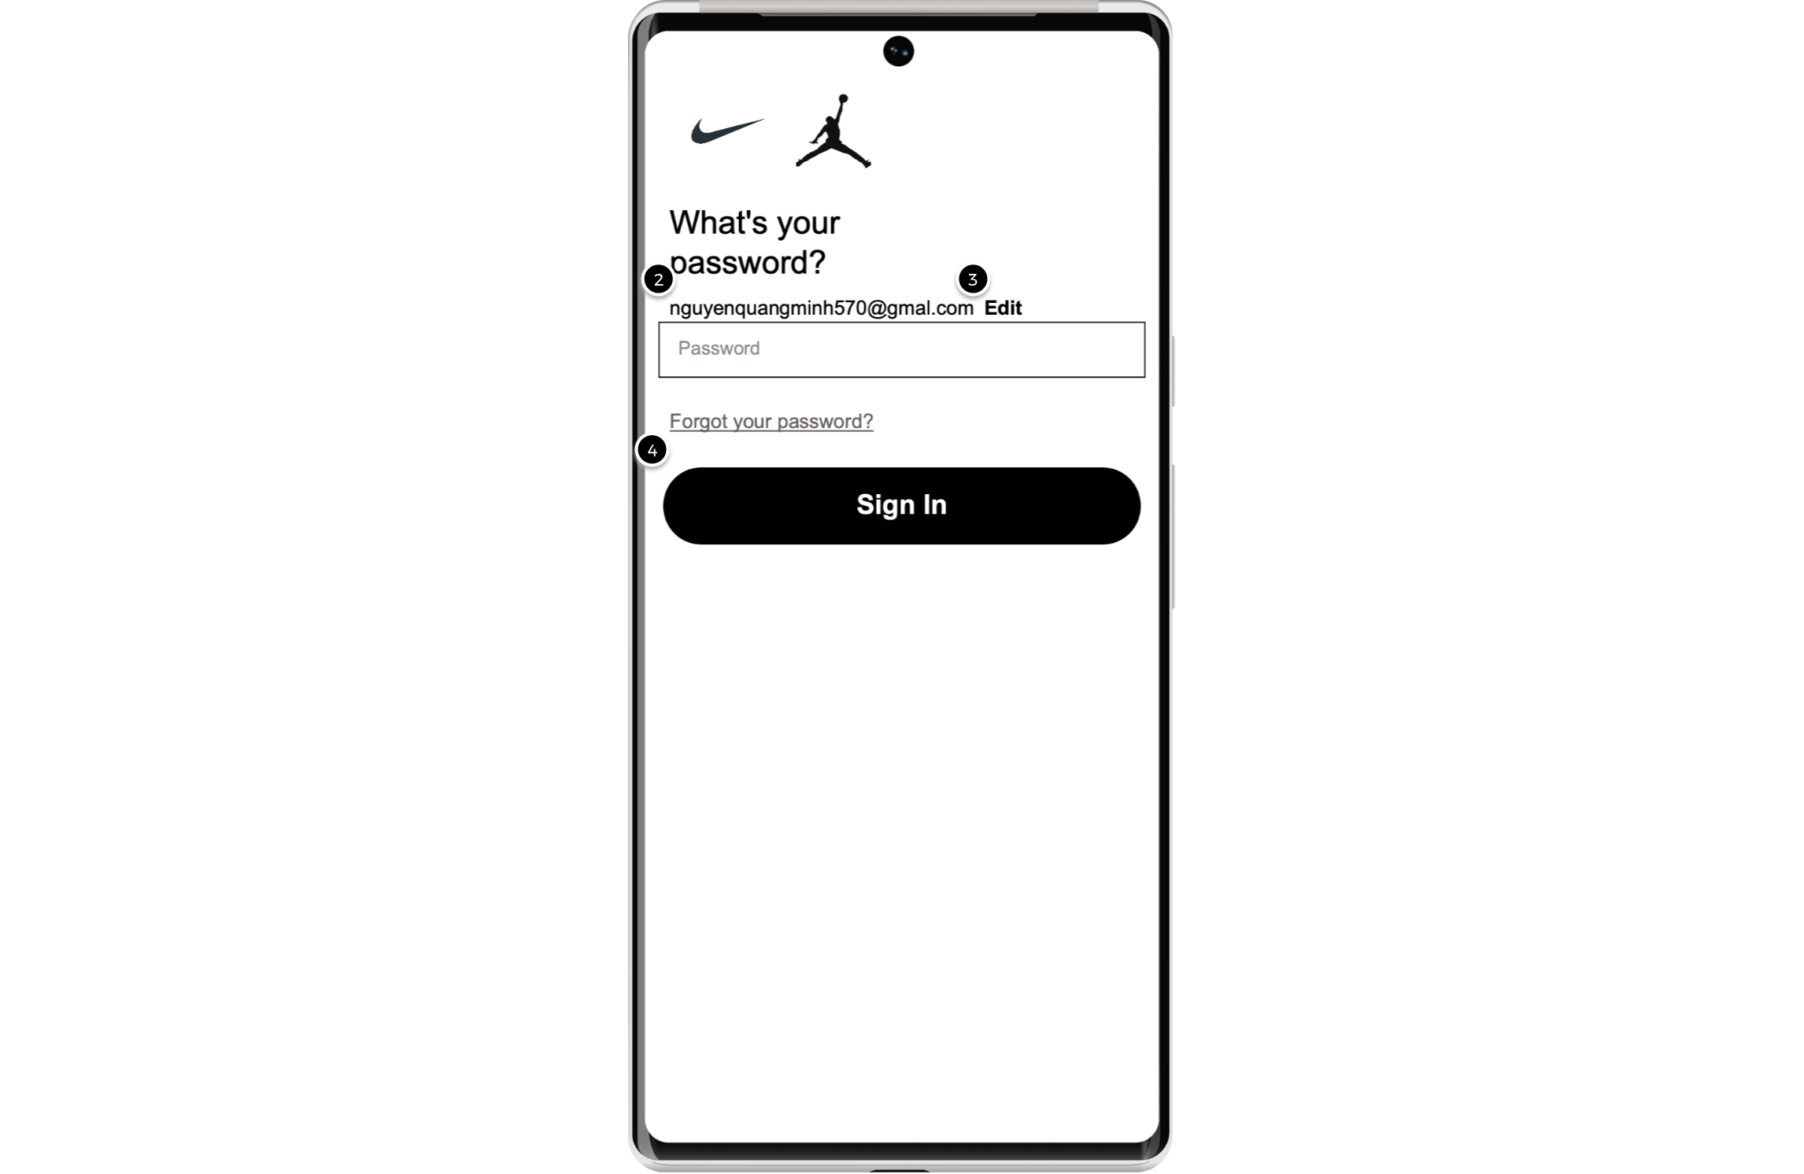

Interactions

3 | on Click: goes to 'Verify Email' with effect: fade in 700ms
4 | on Click: goes to 'HomeScreen' with effect: fade in 700ms

01. Screens / ShoesShop
AuthScreen
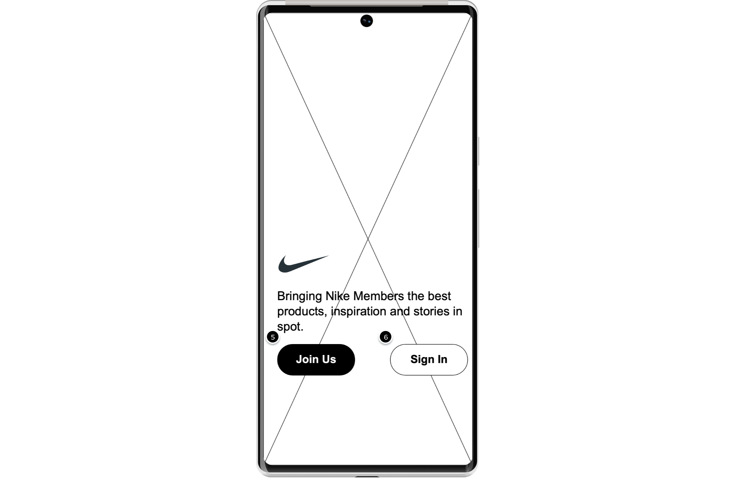

Interactions

5 | on Click: goes to 'Verify Email' with effect: fade in 700ms
6 | on Click: goes to 'Verify Email' with effect: fade in 700ms

01. Screens / ShoesShop
Verify Email
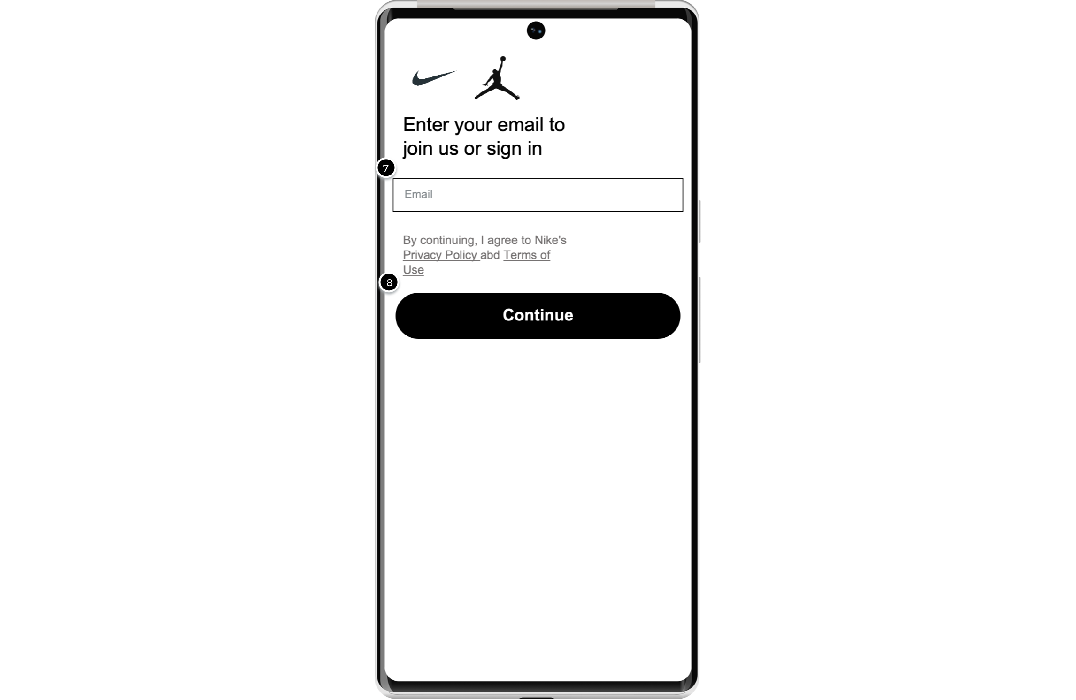

Interactions

8 | on Click: goes to 'LoginScreen' with effect: fade in 700ms

01. Screens / ShoesShop
RegisterScreen
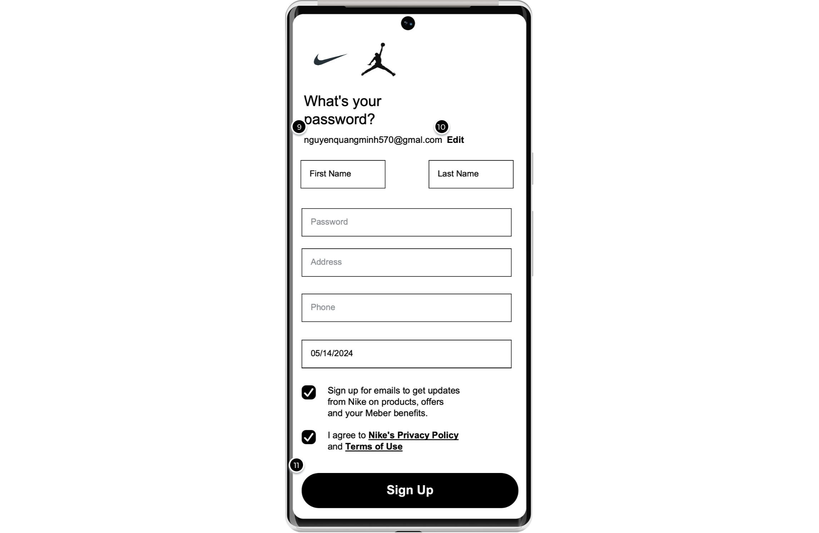

Interactions

10 | on Click: goes to 'Verify Email' with effect: fade in 700ms
11 | on Click: goes to 'LoginScreen' with effect: fade in 700ms

01. Screens / ShoesShop
HomeScreen
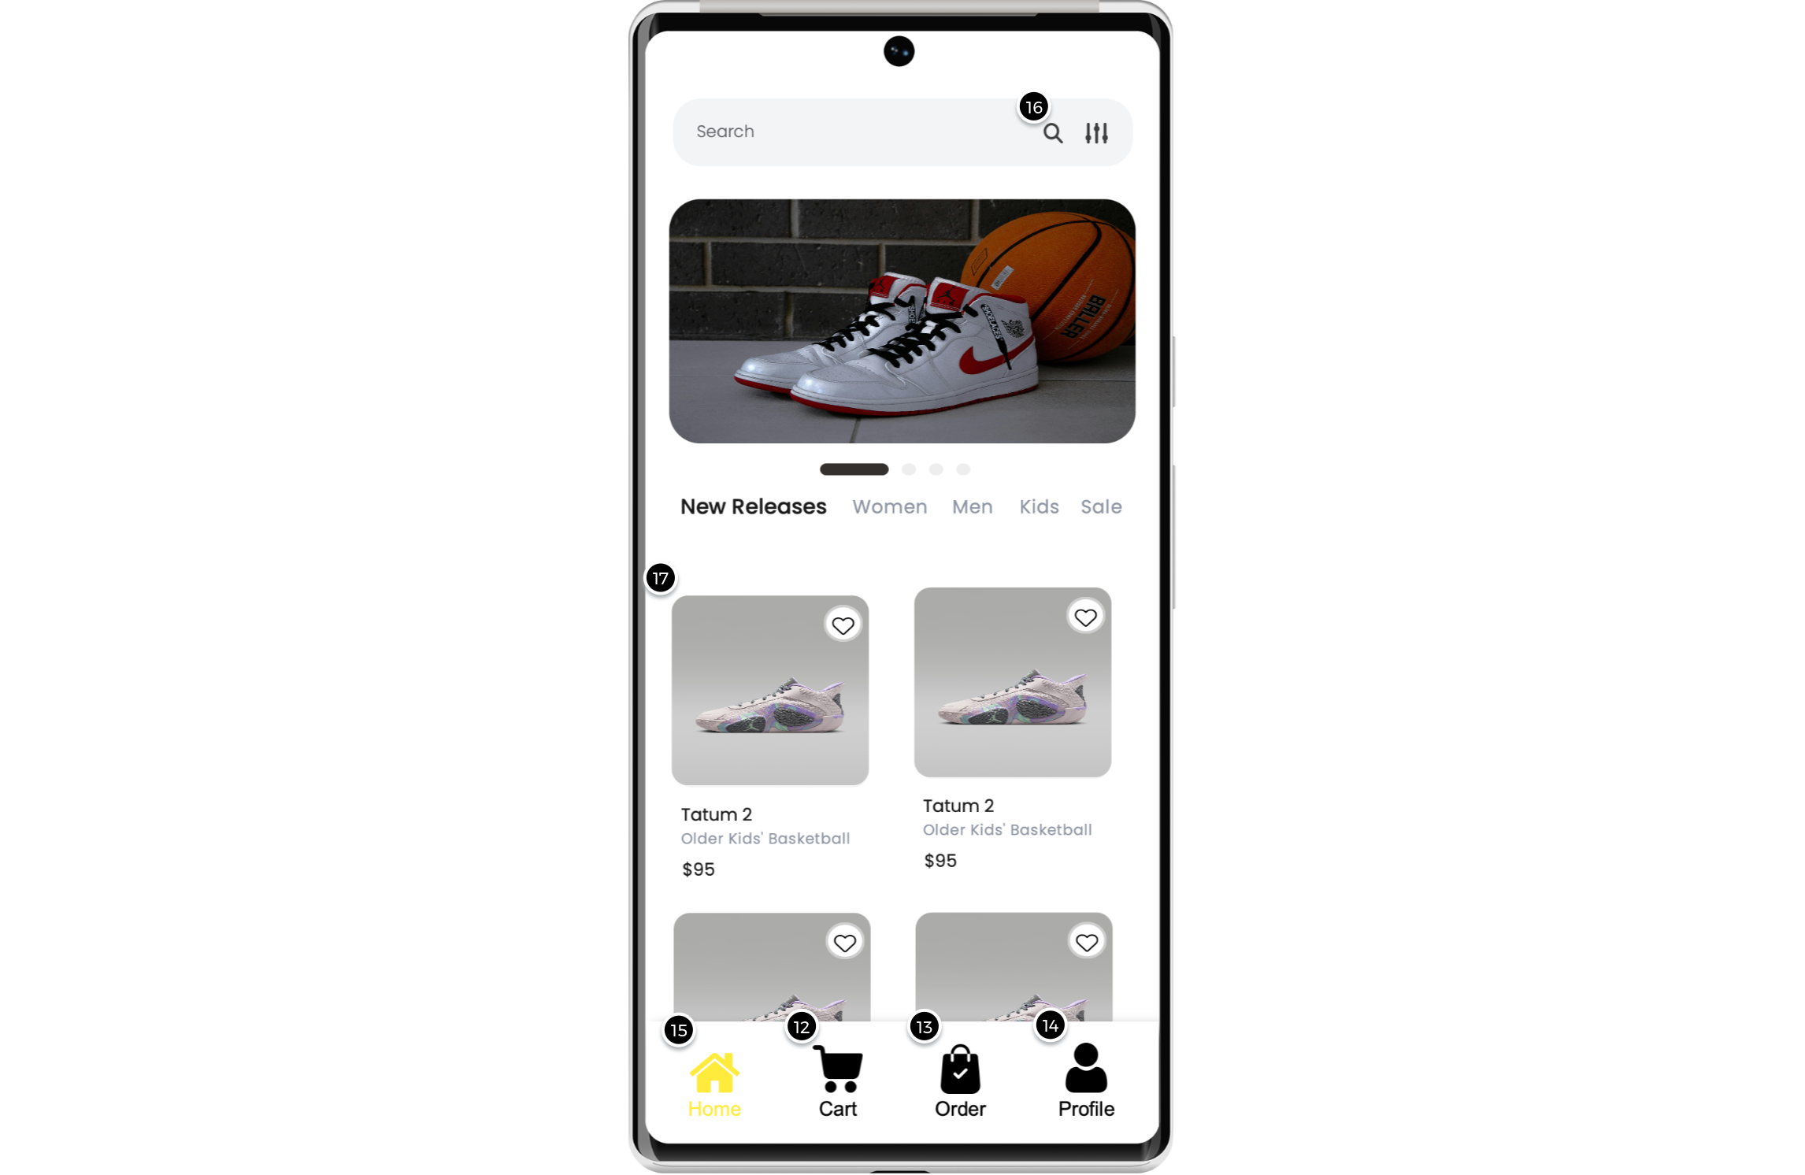

Interactions

12 | on Click: goes to 'CartScreen'
13 | on Click: goes to 'OrderScreen'
14 | on Click: goes to 'ProfileScreen'
15 | on Click: goes to 'HomeScreen'
16 | on Click: goes to 'SearchScreen' with effect: fade in 700ms
17 | on Click: goes to 'DetailScreen'

01. Screens / ShoesShop
CartScreen
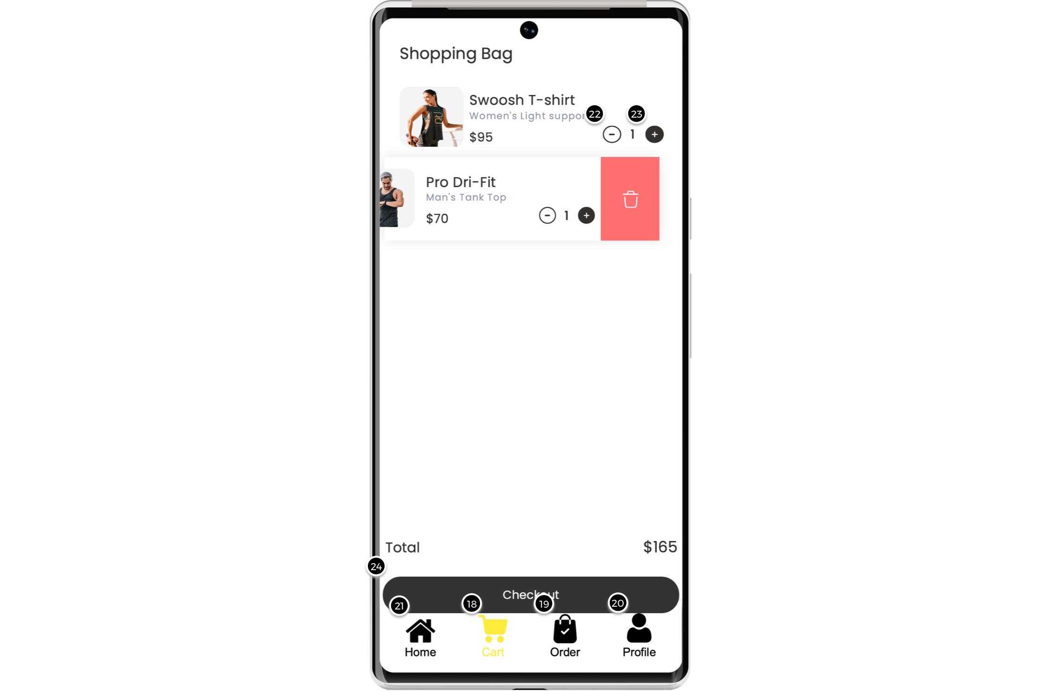

Interactions

18 | on Click: goes to 'CartScreen'
19 | on Click: goes to 'OrderScreen'
20 | on Click: goes to 'ProfileScreen'
21 | on Click: goes to 'HomeScreen'
24 | on Click: goes to 'CheckoutScreen'

01. Screens / ShoesShop
OrderScreen
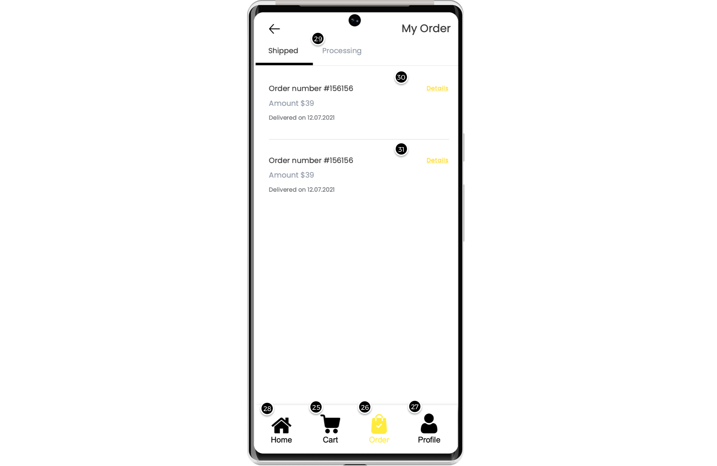

Interactions

25 | on Click: goes to 'CartScreen'
26 | on Click: goes to 'OrderScreen'
27 | on Click: goes to 'ProfileScreen'
28 | on Click: goes to 'HomeScreen'
29 | on Click: goes to 'OrderTrackingScreen'
30 | on Click: goes to 'OrderDetailScreen'
31 | on Click: goes to 'OrderTrackingScreen'

01. Screens / ShoesShop
ProfileScreen
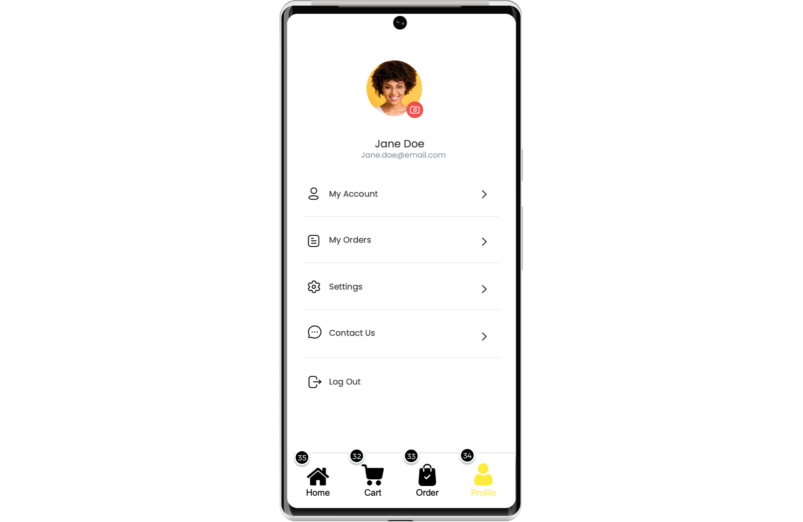

Interactions

32 | on Click: goes to 'CartScreen'
33 | on Click: goes to 'OrderScreen'
34 | on Click: goes to 'ProfileScreen'
35 | on Click: goes to 'HomeScreen'

01. Screens / ShoesShop
SearchScreen
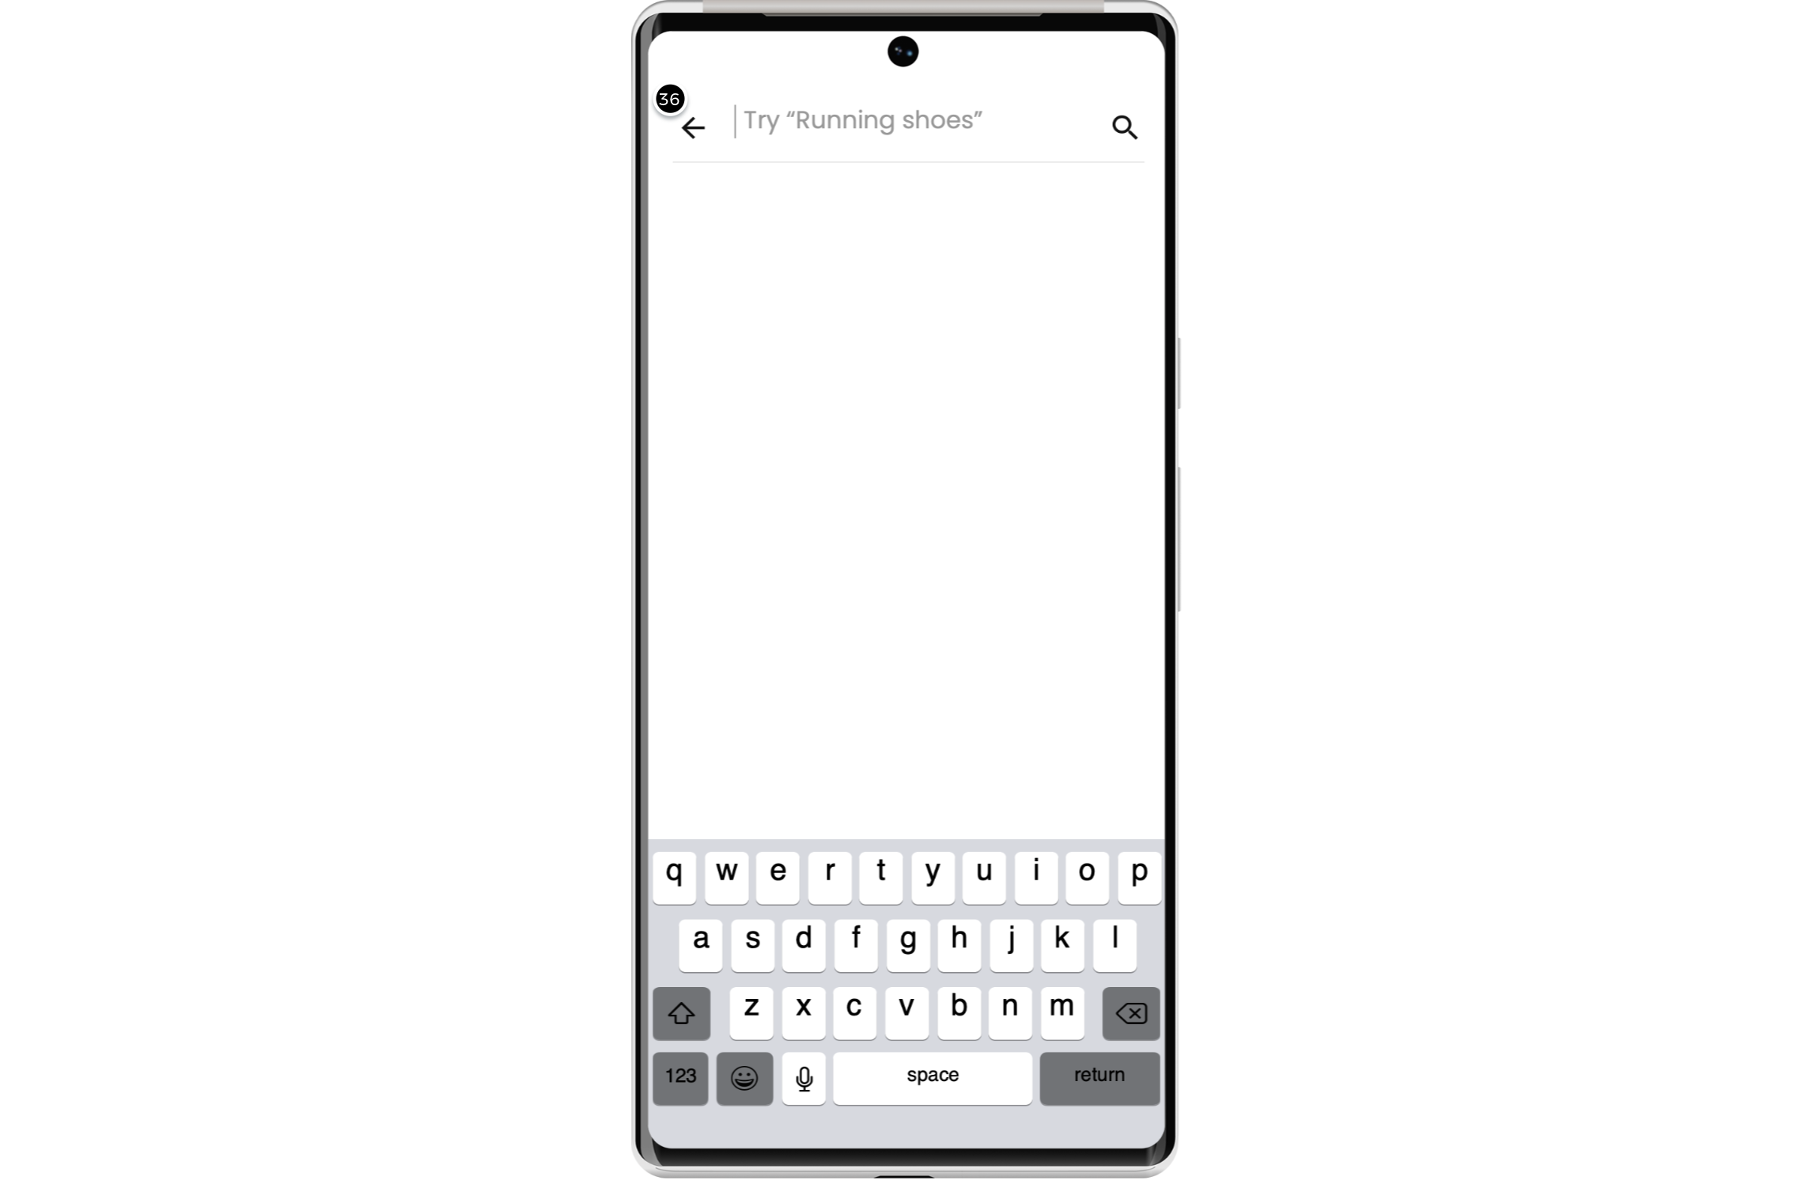

Interactions

36 | on Click: goes to 'HomeScreen' with effect: fade in 700ms

01. Screens / ShoesShop
DetailScreen
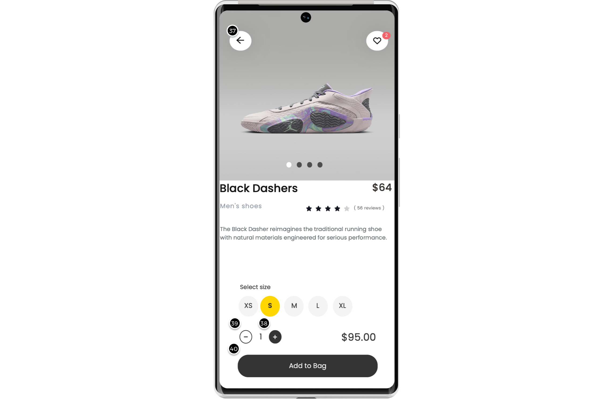

Interactions

37 | on Click: goes to 'HomeScreen'
40 | on Click: goes to 'CartScreen'

01. Screens / ShoesShop
CheckoutScreen
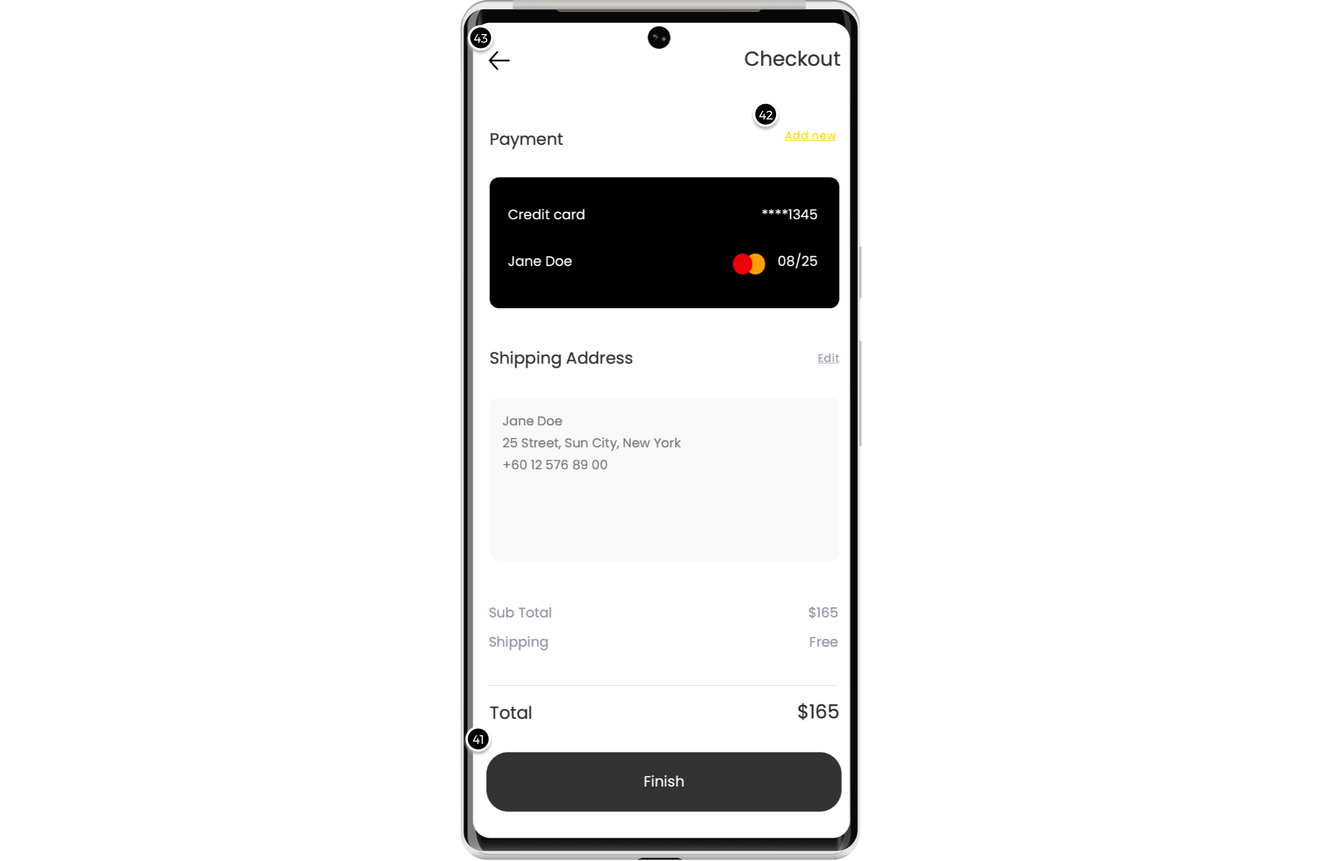

Interactions

41 | on Click: goes to 'OrderCompleteScreen'
42 | on Click: goes to 'AddNewCardScreen'
43 | on Click: goes to 'OrderScreen'

01. Screens / ShoesShop
AddNewCardScreen
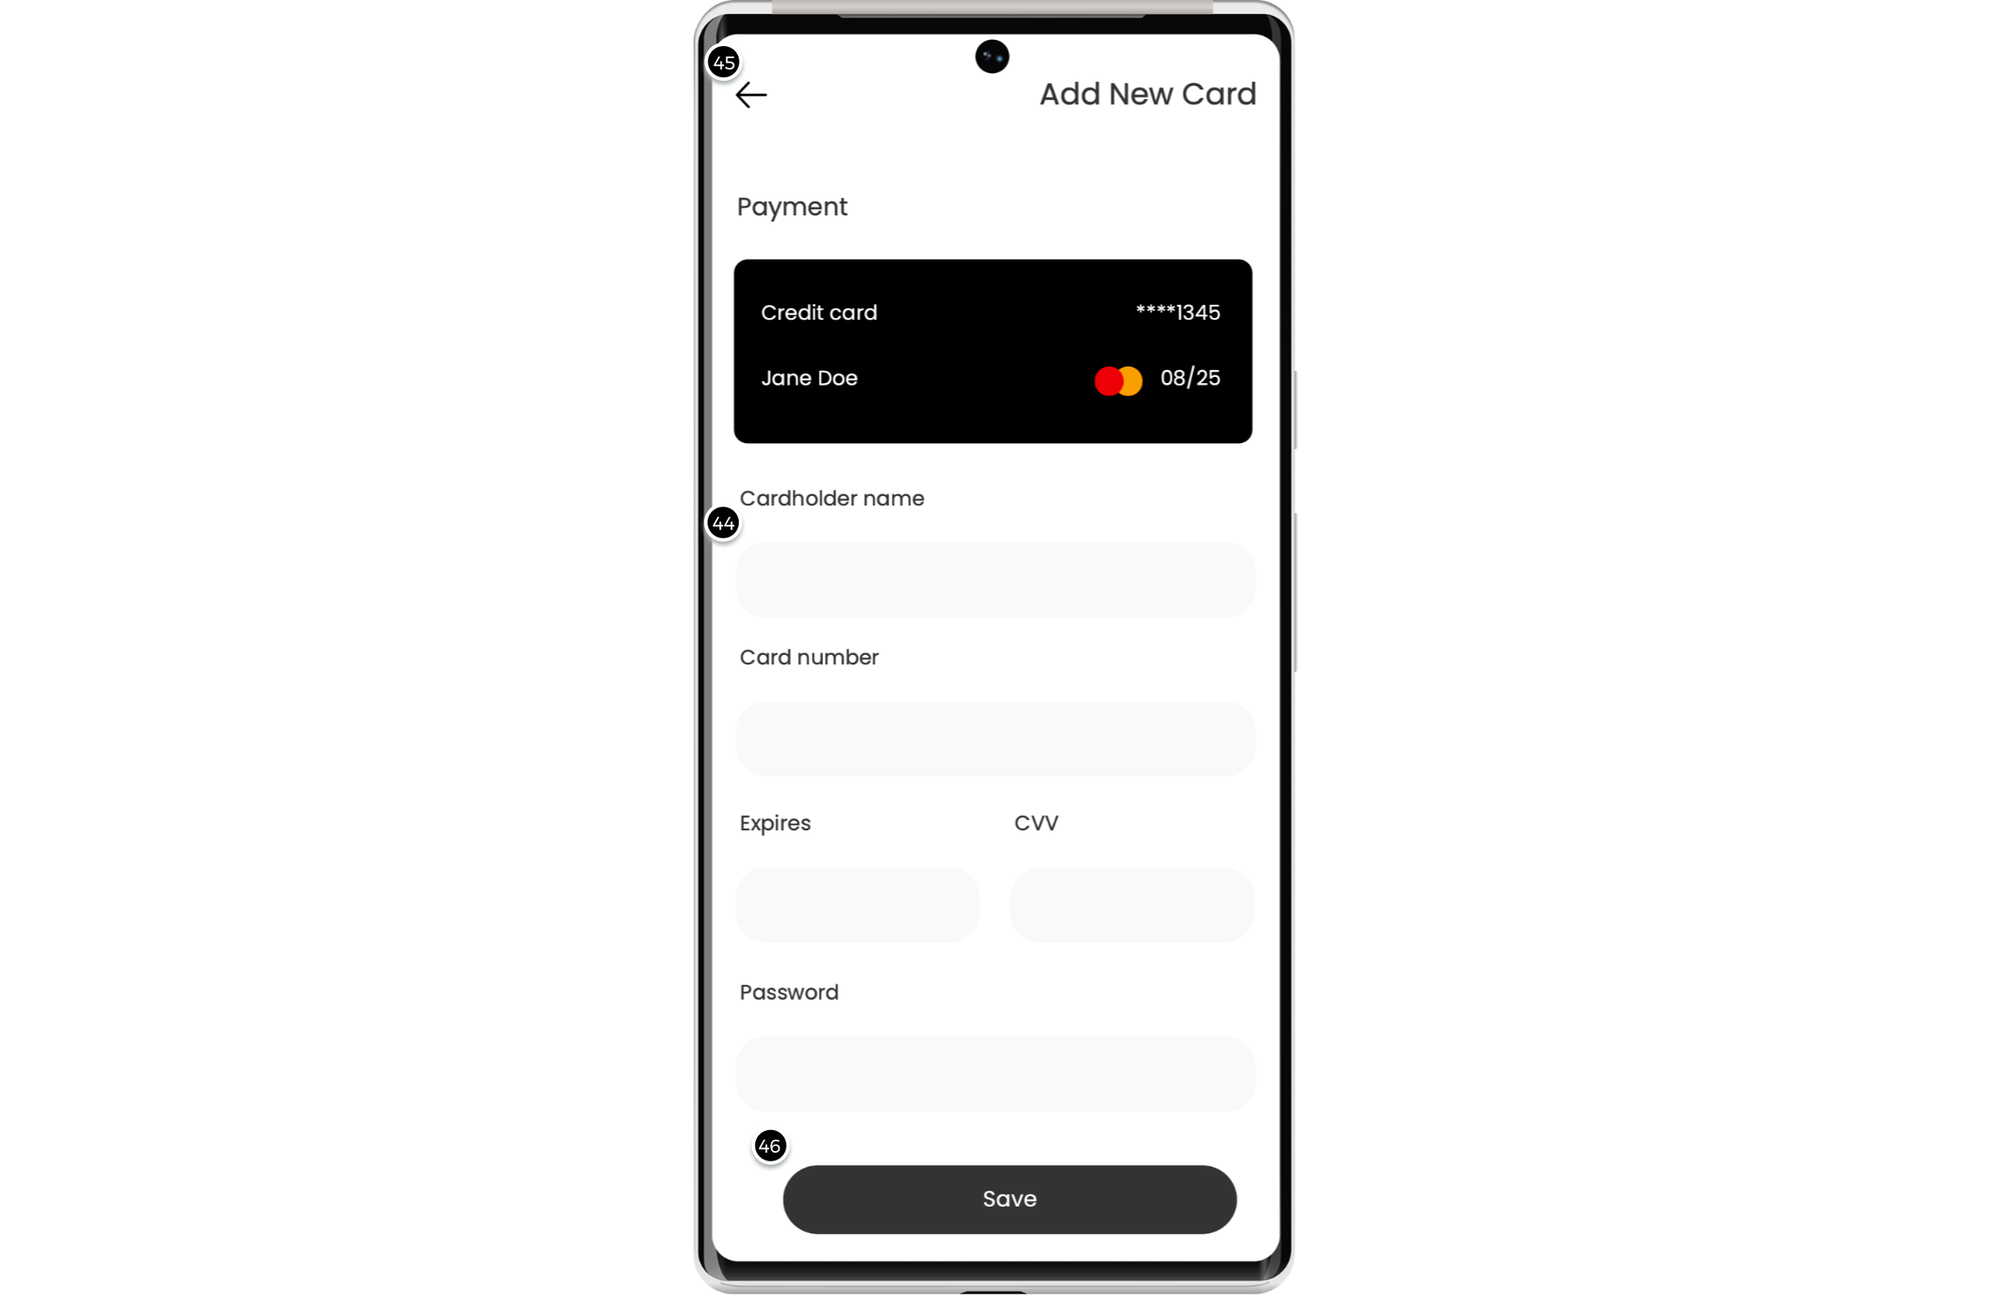

Interactions

45 | on Click: goes to 'CheckoutScreen'
46 | on Click: goes to 'DetailScreen'

01. Screens / ShoesShop
OrderCompleteScreen
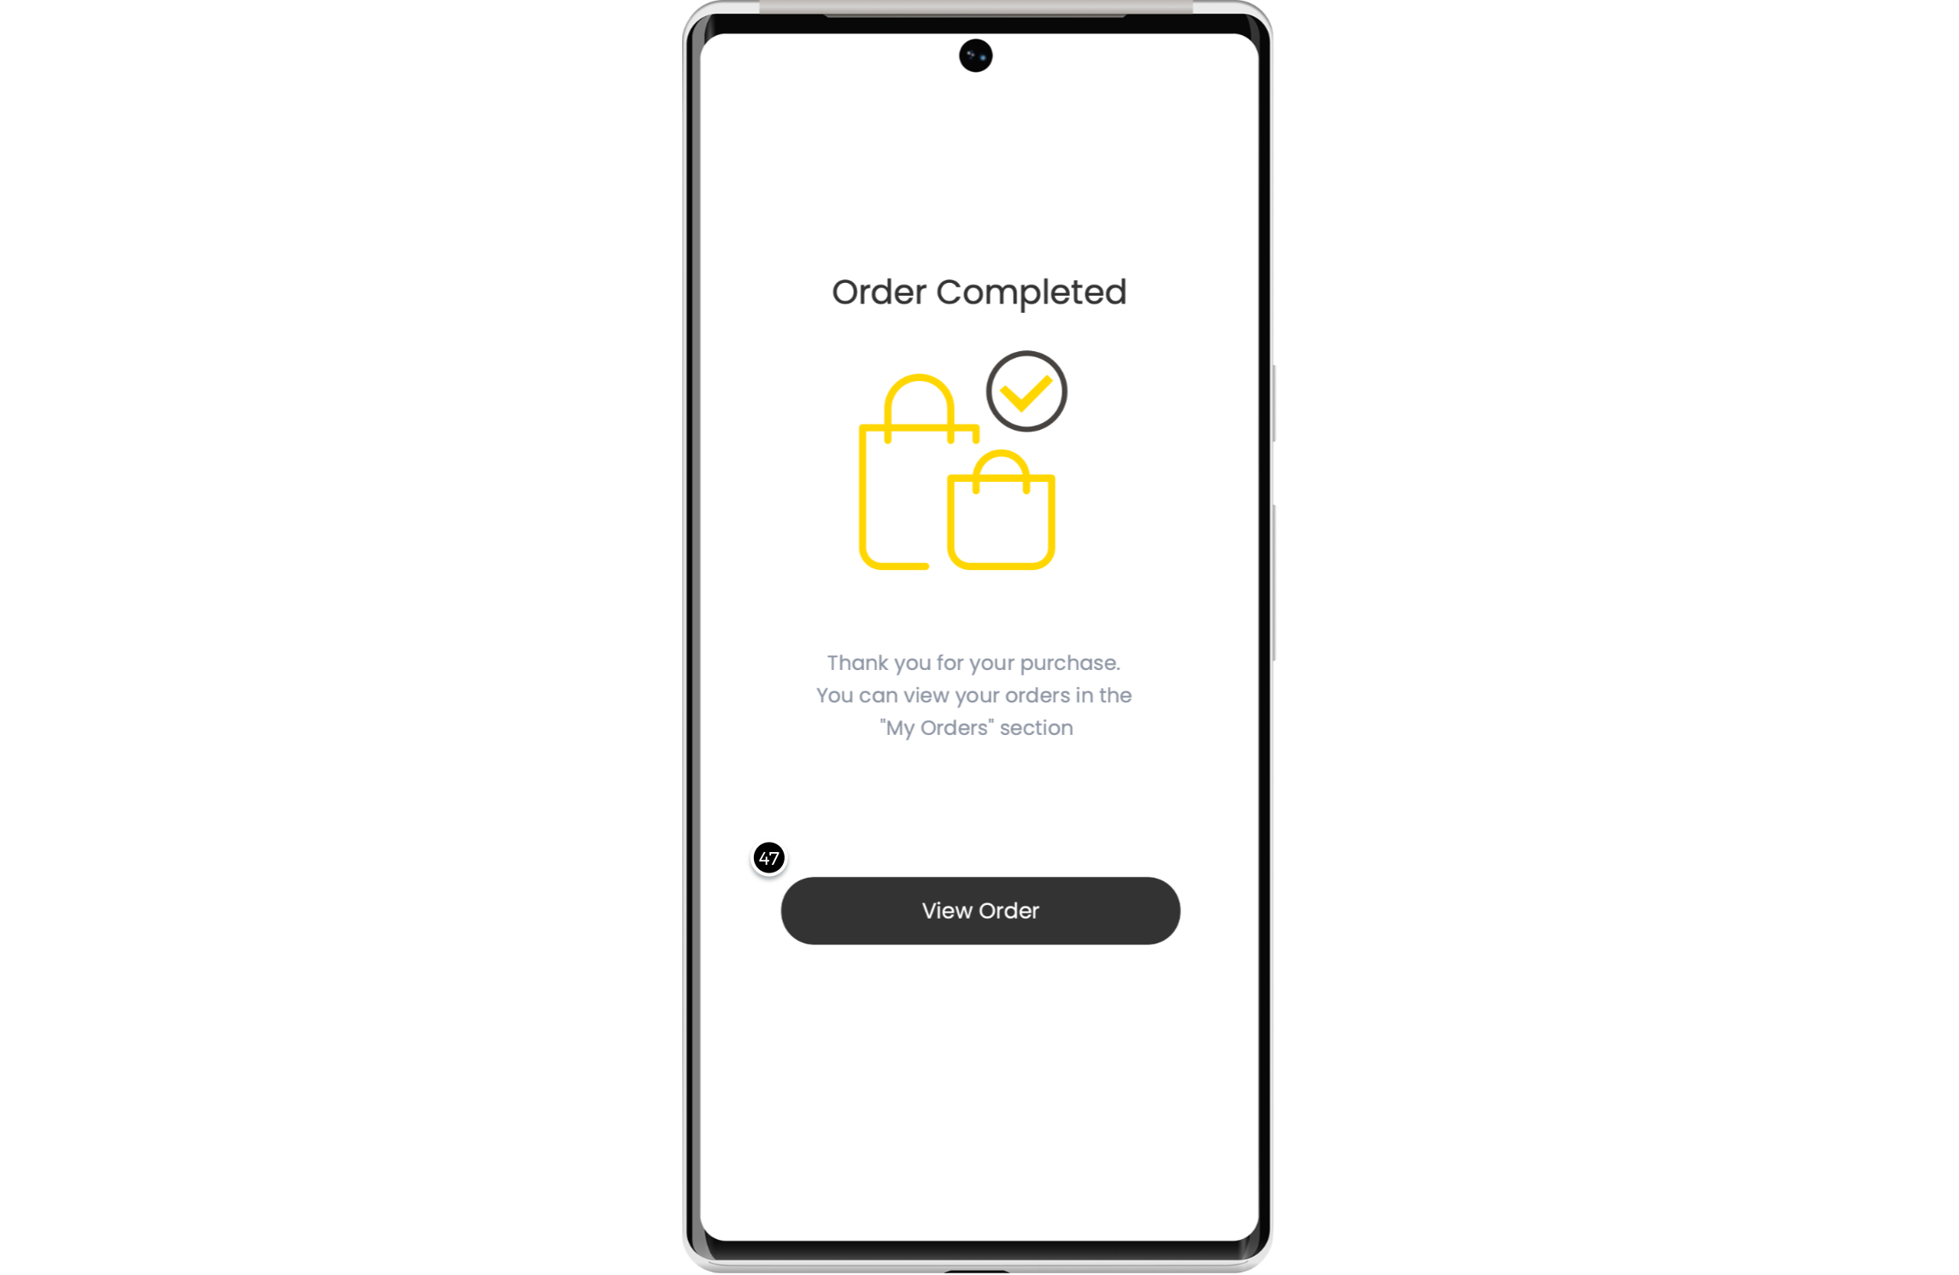

Interactions

47 | on Click: goes to 'OrderScreen'

01. Screens / ShoesShop
OrderDetailScreen
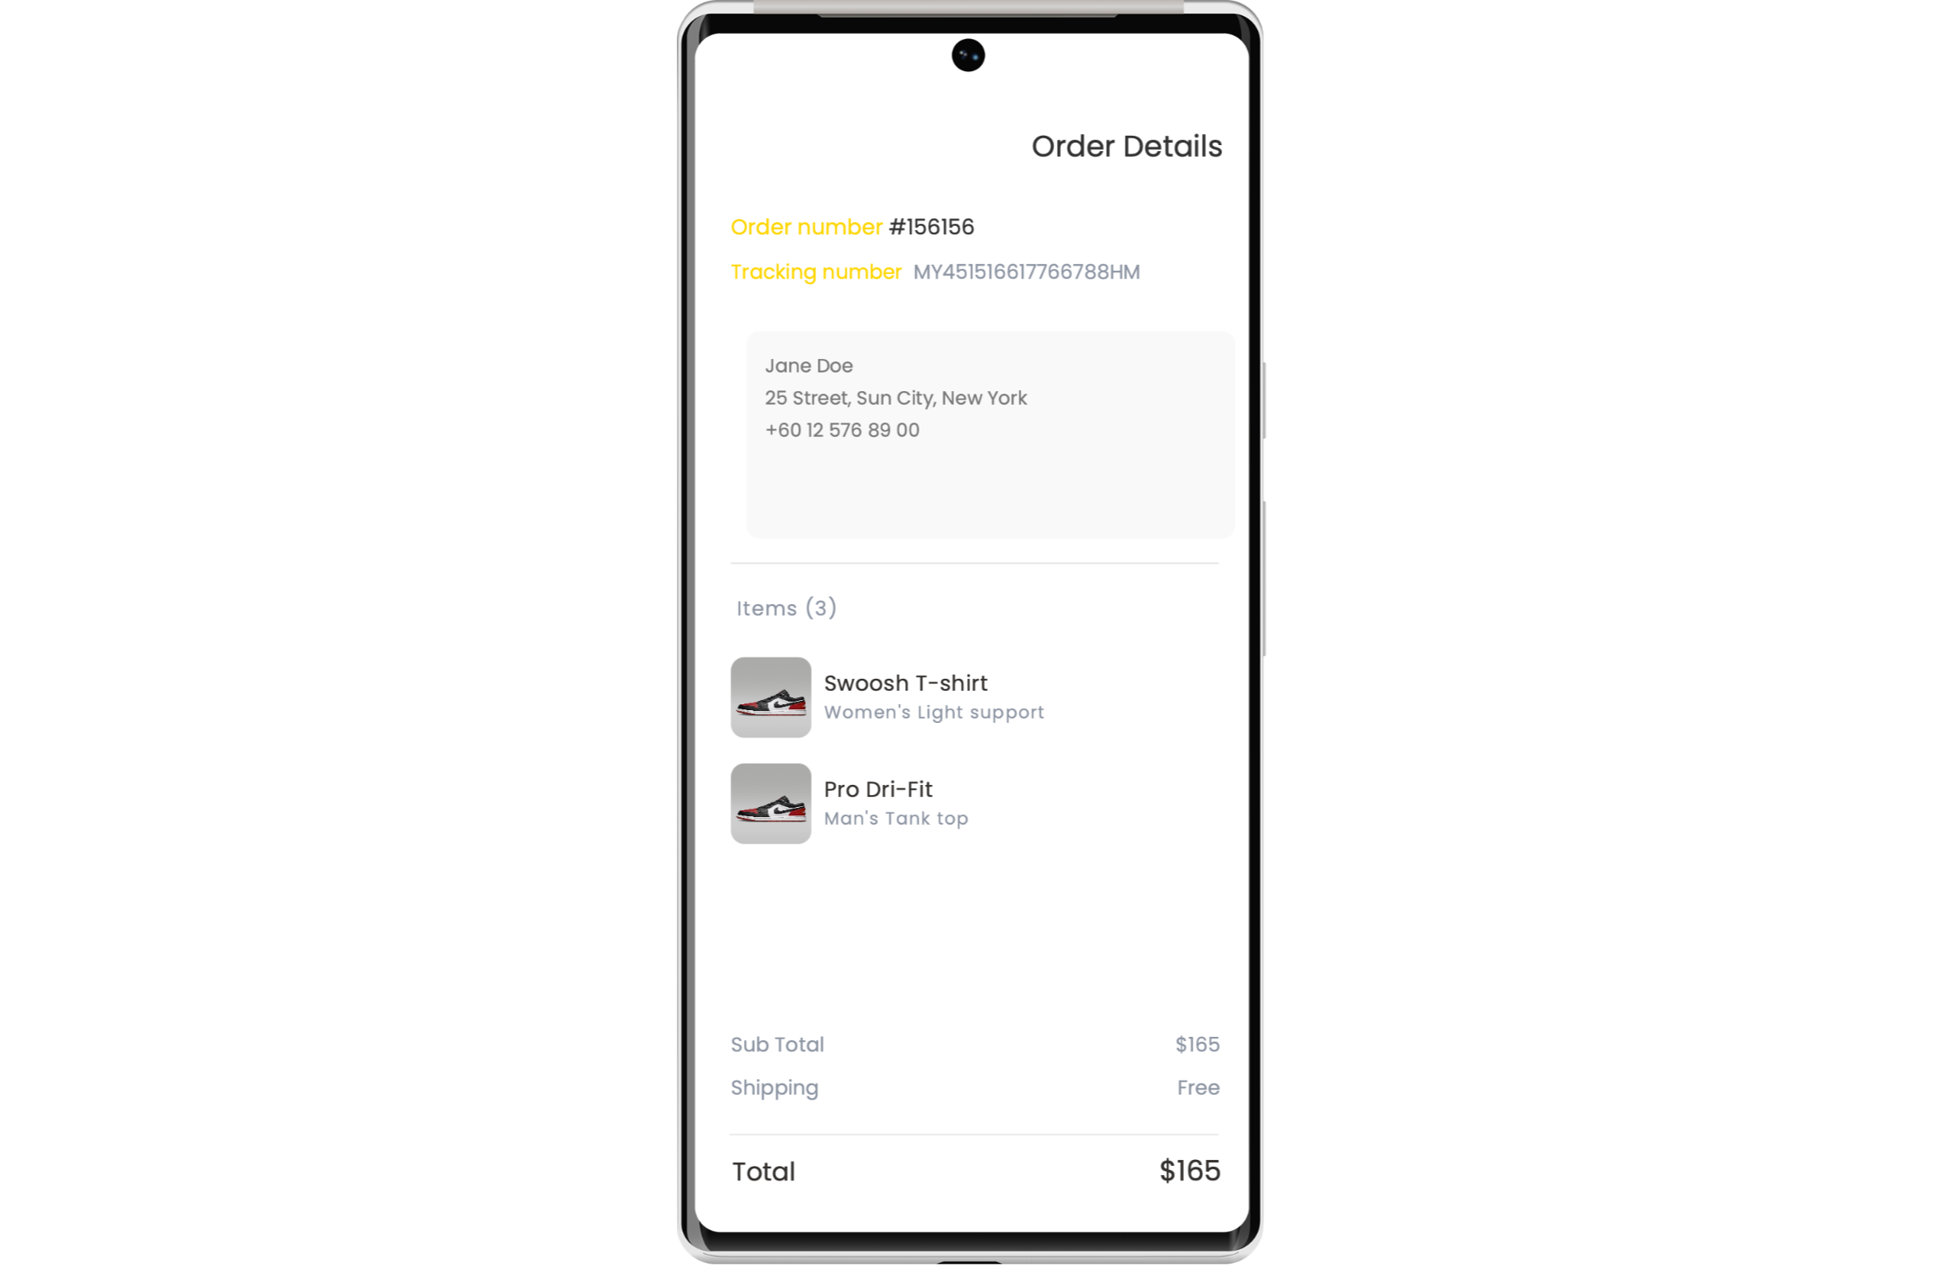

01. Screens / ShoesShop
OrderTrackingScreen
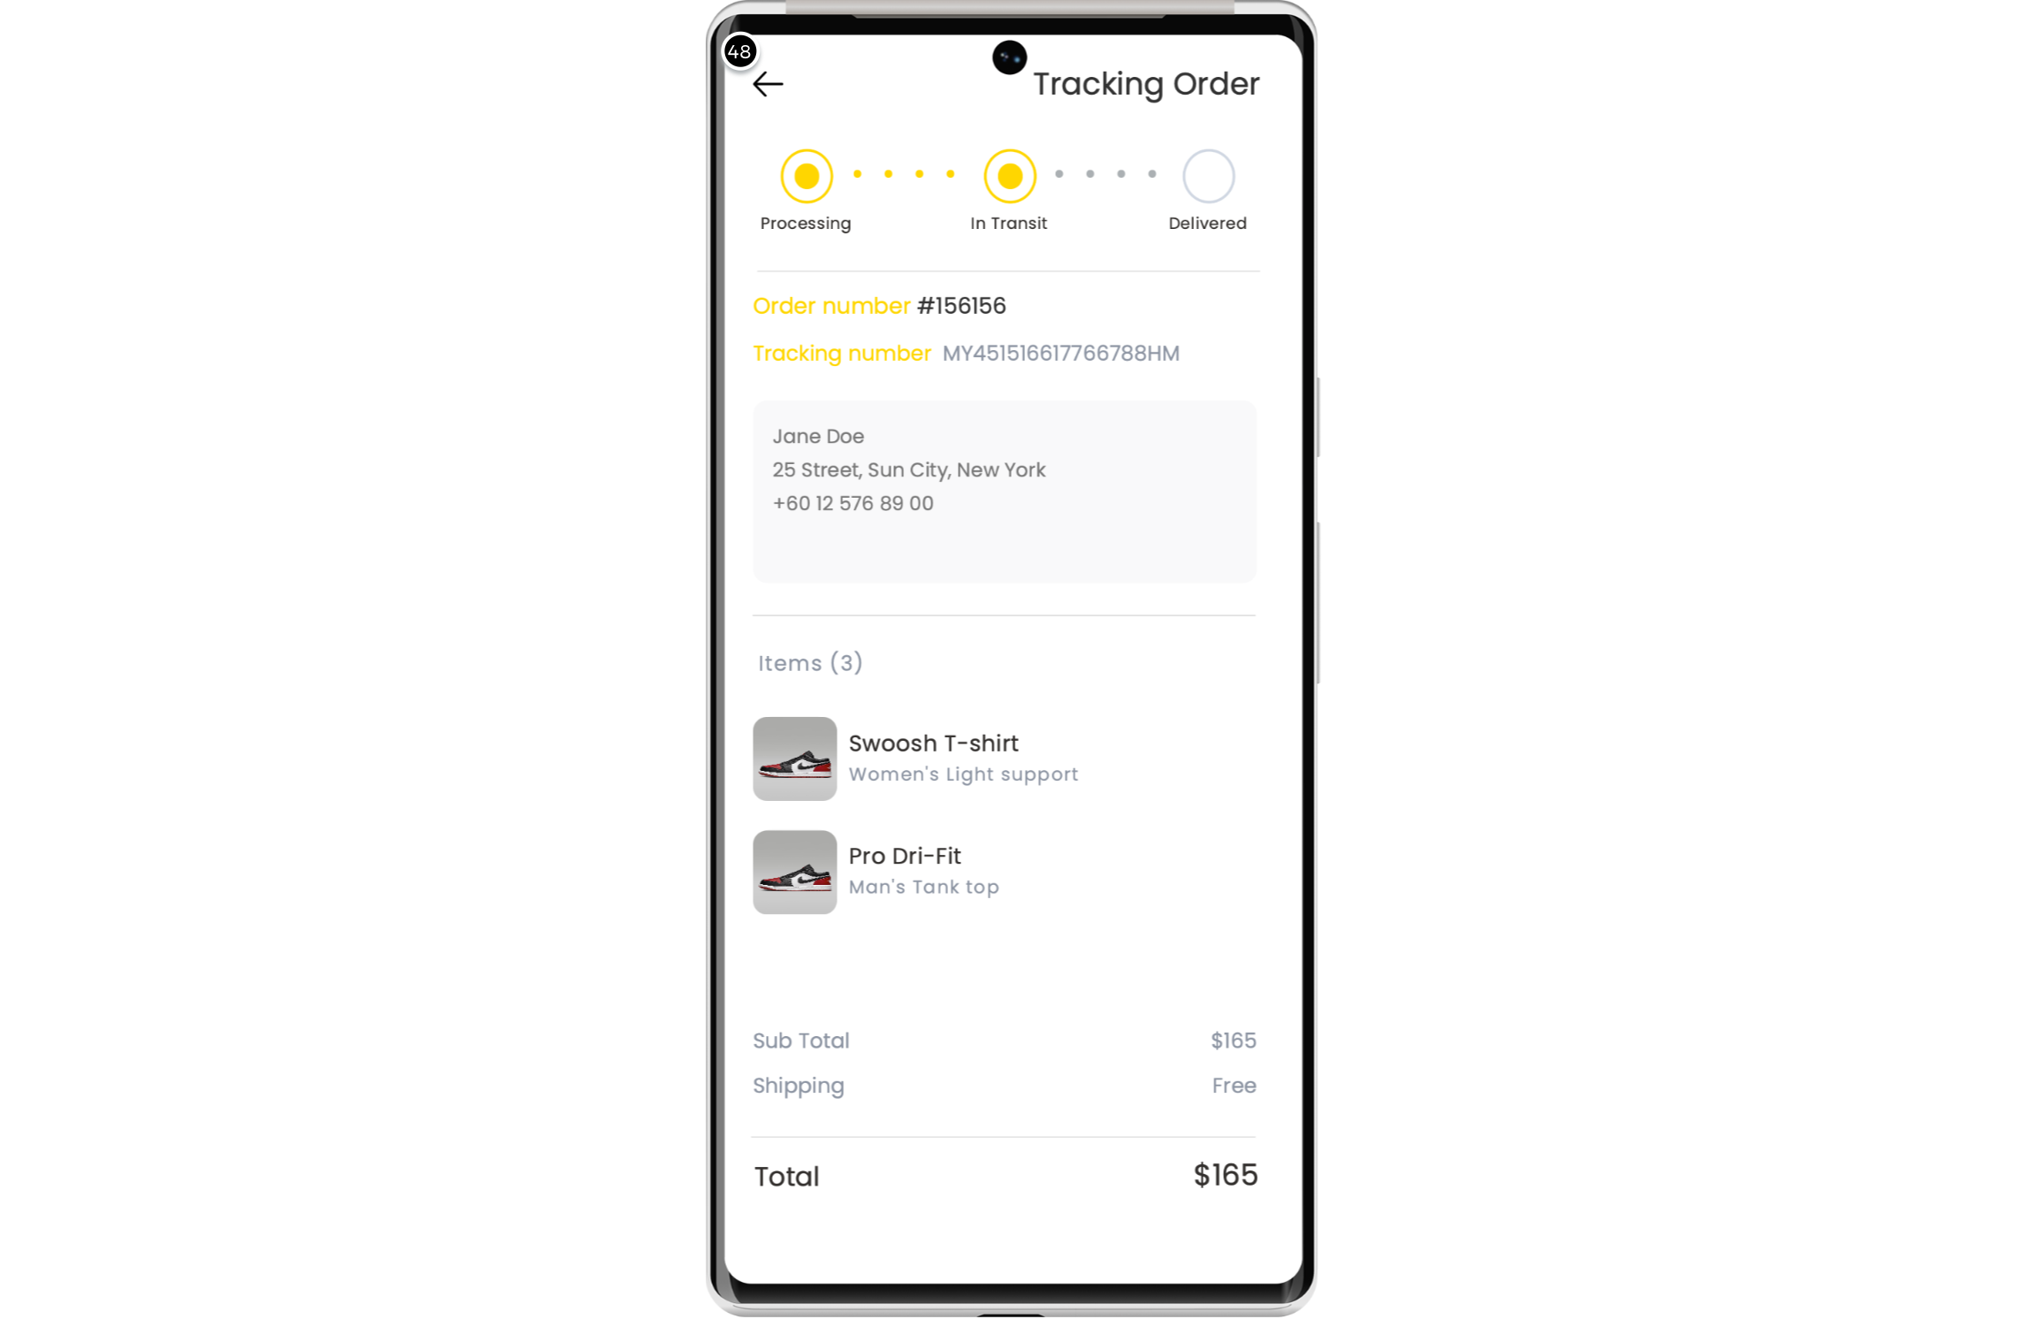

Interactions

48 | on Click: goes to 'OrderScreen'

01. Screens / ShoesShop
RatingScreen
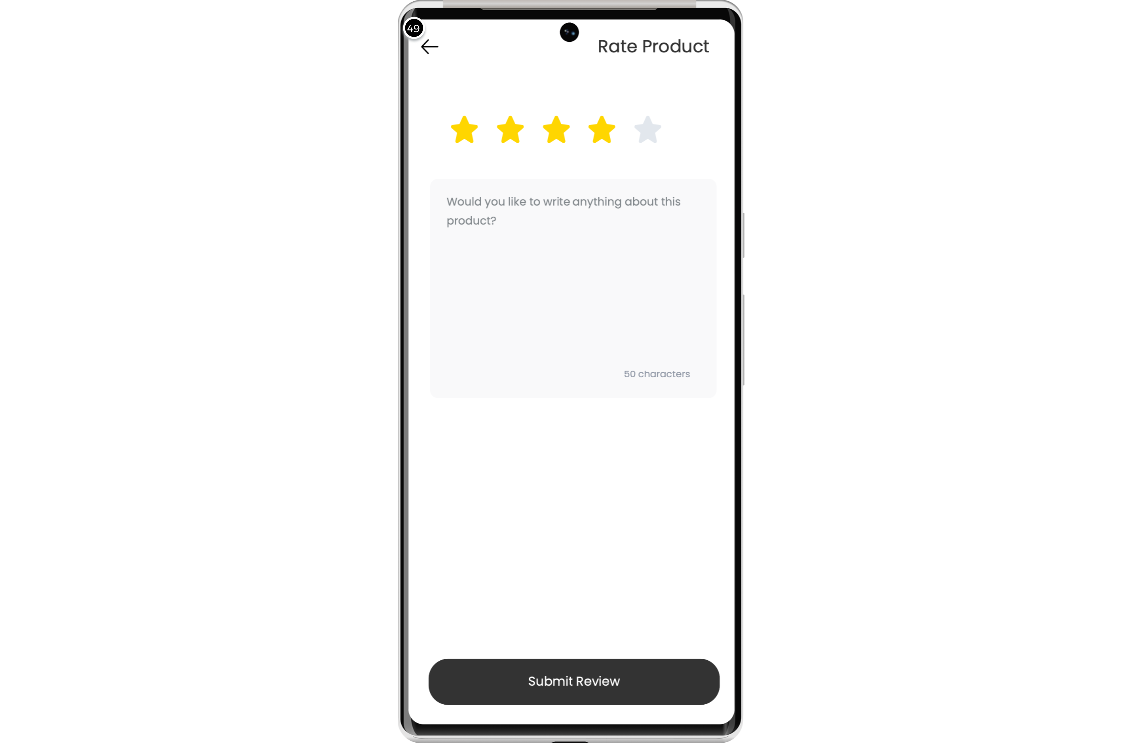

Interactions

49 | on Click: goes to 'DetailScreen'

Templates
02

02. Templates / ShoesShop
Template 1
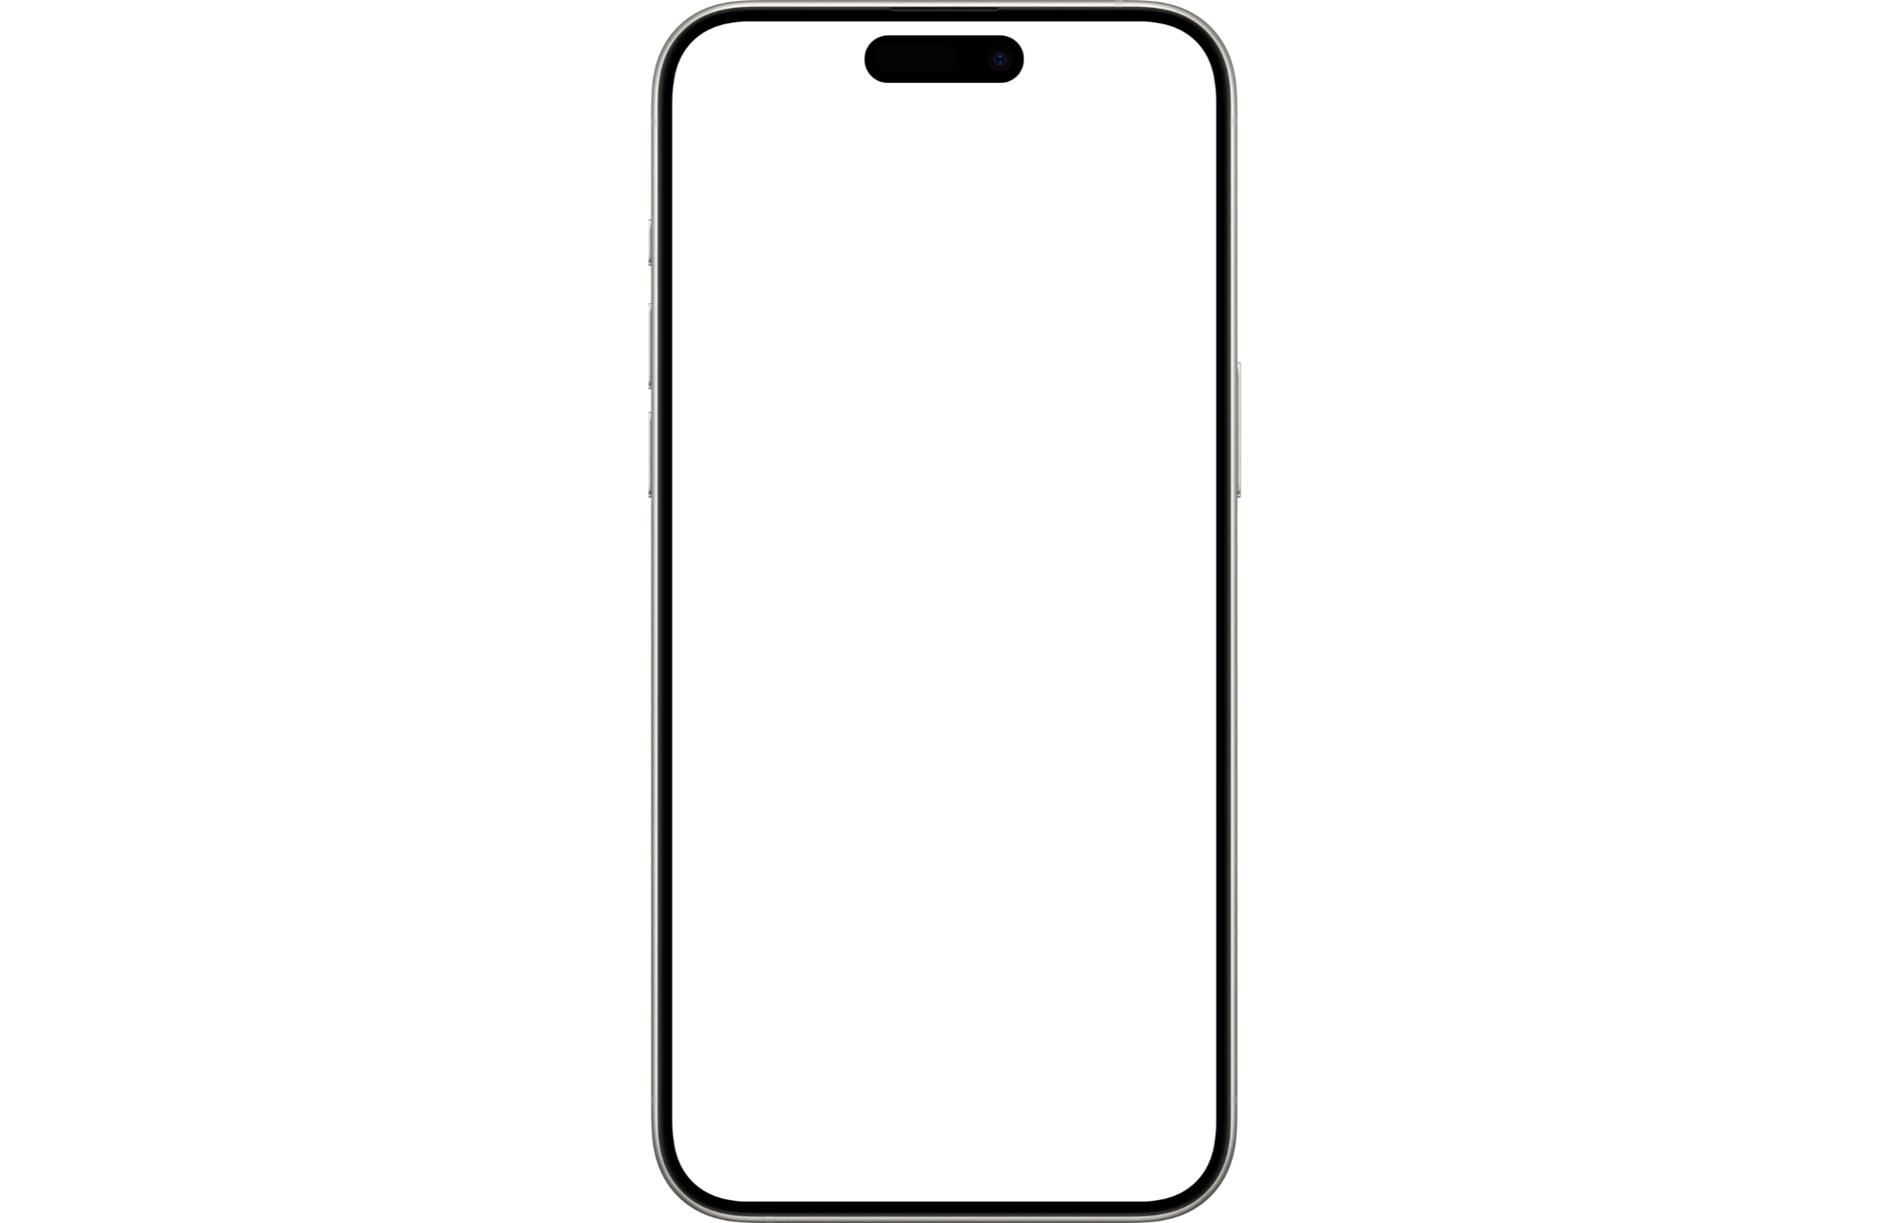

Scenarios
03

03. Scenarios / ShoesShop
default


